Save the Pod: Game Play

[[Game Play video link](https://drive.google.com/file/d/1Lu9j93m4z_3o21UGwGf2uP7susCLAhyu/view?usp=sharing): https://drive.google.com/file/d/1Lu9j93m4z_3o21UGwGf2uP7susCLAhyu/view?usp=sharing]

* **Start Game:**

Open the command prompt.

Run command: *<path_to_python.exe><space><path_to_main.py>*

Press Enter and the Game window will open.

* **Welcome Window:**

The welcome window looks as shown. Press any key to continue.

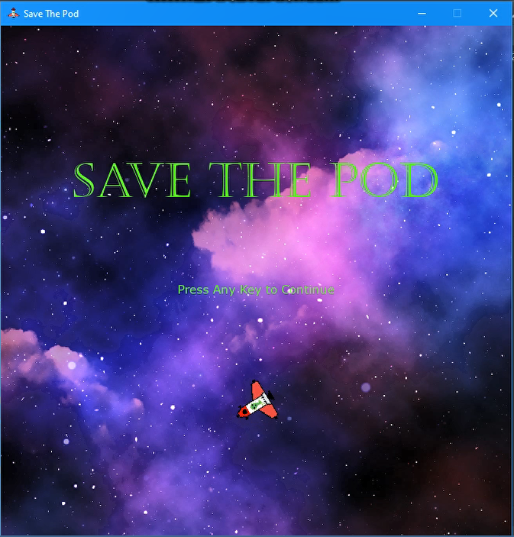

* **Main Menu Window:**

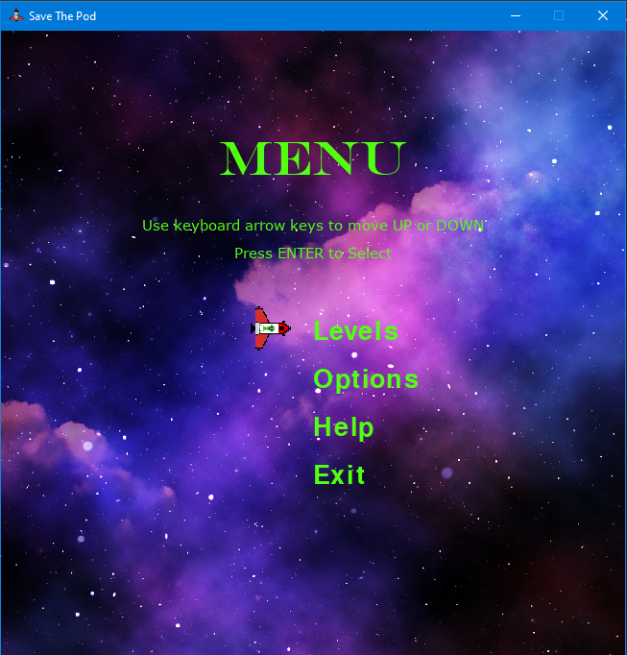

Navigate up or down using the up/down arrow keys on the keyboard. Press Enter to select.

*Levels* options contain all levels. Select Levels options and the select level you want to play.

Select *Options* to turn on/off gravity, fuel, music, and sound.

Select *Help* to read instructions on “How to play”.

To close the game select *Exit*.

* **Levels Window:**

It contains all levels with your current score.

Use the keyboard left/right arrow key to navigate. Press Enter to start the respective level.

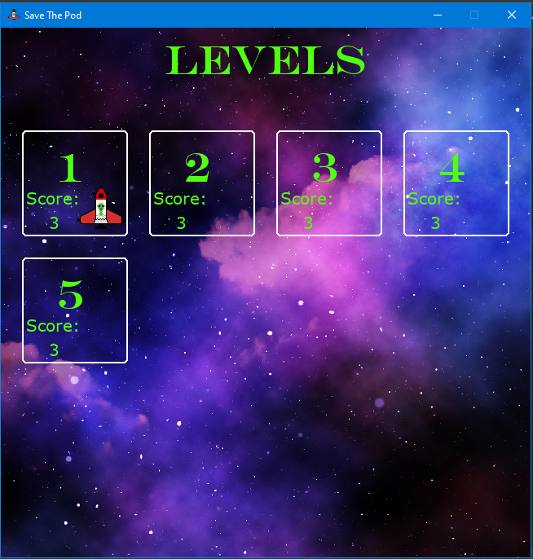

* **Options Window:**

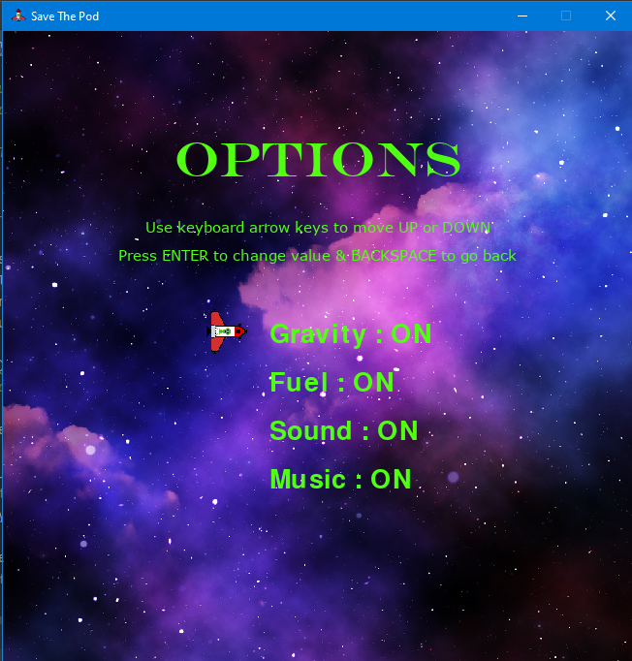

It contains options to turn on/off gravitational pull from planets and black holes, fuel measurement, background music, and sound.

Navigate up or down using the up/down arrow keys on the keyboard. Press Enter to toggle on/off value.

* **Help Window:**

Read instructions on how to play.

|  |  |
| --- | --- |
| Use:   * + “A” for moving Left   + “S” for moving Down   + “D” for moving Right   + “W” for moving Forward   + “Left Arrow key” for rotating pod counterclockwise   + “Right Arrow key” for rotating pod clockwise |  |

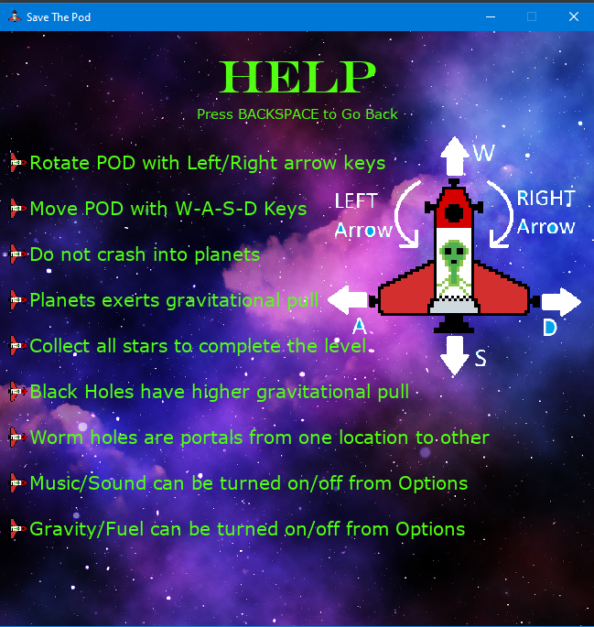

* **Game Window:**

|  |  |
| --- | --- |
| * The actual game begins here. * Assume you're in a spaceship (small space capsule). * You must maneuver the pod to avoid colliding with planets or black holes. * To complete the level before the fuel runs out, you must gather all the stars. * There will be wormholes for teleporting pods between wormholes. * Gravitational pull is represented by grey rings surrounding planets and black holes. * Remember that black holes have a stronger gravitational attraction than planets.   Some info is presented at the top of the screen.   * Vx: Pod velocity in the x-direction * Vy: Pod velocity in the  y-direction * Angle: The pod's orientation. * Score: Number of stars collected * Fuel: The remaining fuel in the pod. |  |